Name: Jorune Simpkins
Lab: 1C_bonus_D
Document Topic: Student Deliverables
Date: 1/31/2026
Note: Student verification (CLI) — DNS + Logs
Why this matters to YOU (career-critical point)
This is incident response fuel:
Access logs tell you:
- client IPs
- paths
- response codes
- target behavior
- latency
Combined with WAF logs/metrics and ALB 5xx alarms, you can do real triage:
“Is it attackers, misroutes, or downstream failure?”

1) Verify apex record exists
aws route53 list-resource-record-sets \
--hosted-zone-id <ZONE_ID> \
--query "ResourceRecordSets[?Name=='chewbacca-growl.com.']"

- COMMAND RUN:
aws route53 list-resource-record-sets \
--hosted-zone-id Z0577510JJCMGIYZ7086 \
--query "ResourceRecordSets[?Name=='firstpointand.click.']"

- OUTPUT:
jorun@Simpkij3421 MINGW64 ~/documents/theowaf/armageddon/armageddon_repo/armageddon_clone/1c_bonus_D (main)
$ aws route53 list-resource-record-sets --hosted-zone-id Z0577510JJCMGIYZ7086 --query "ResourceRecordSets[?Name=='firstpointand.click.']"
[
{
"Name": "firstpointand.click.",
"Type": "NS",
"TTL": 172800,
"ResourceRecords": [
{
"Value": "ns-521.awsdns-01.net."
},
{
"Value": "ns-125.awsdns-15.com."
},
{
"Value": "ns-1573.awsdns-04.co.uk."
},
{
"Value": "ns-1482.awsdns-57.org."
}
]
},
{
"Name": "firstpointand.click.",
"Type": "SOA",
"TTL": 900,
"ResourceRecords": [
{
"Value": "ns-521.awsdns-01.net. awsdns-hostmaster.amazon.com. 1 7200 900 1209600 86400"
}
]
}
]
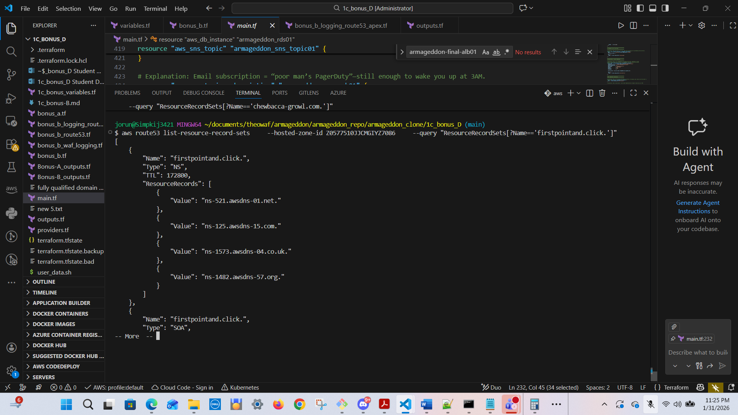
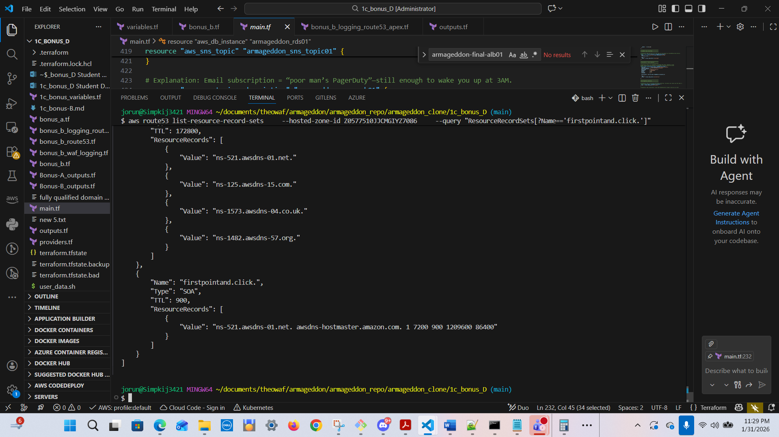

2) Verify ALB logging is enabled
aws elbv2 describe-load-balancers \
--names chewbacca-alb01 \
--query "LoadBalancers[0].LoadBalancerArn"
2. COMMAND RUN:
jorun@Simpkij3421 MINGW64 ~/documents/theowaf/armageddon/armageddon_repo/armageddon_clone/1c_bonus_D (main)
$ aws elbv2 describe-load-balancers --names armageddon-final-alb01 --query "LoadBalancers[0].LoadBalancerArn"
- OUTPUT
"arn:aws:elasticloadbalancing:us-east-1:975598471165:loadbalancer/app/armageddon-final-alb01/039bcb1fee4c68d2"

Then:
aws elbv2 describe-load-balancer-attributes \
--load-balancer-arn <ALB_ARN>
2. OUTPUT
jorun@Simpkij3421 MINGW64 ~/documents/theowaf/armageddon/armageddon_repo/armageddon_clone/1c_bonus_D (main)
$ aws elbv2 describe-load-balancer-attributes \
--load-balancer-arn arn:aws:elasticloadbalancing:us-east-1:975598471165:loadbalancer/app/armageddon-final-alb01/039bcb1fee4c68d2
{
"Attributes": [
{
"Key": "access_logs.s3.enabled",
"Value": "true"
},
{
"Key": "access_logs.s3.bucket",
"Value": "armageddon-final-alb-logs-975598471165"
},
{
"Key": "access_logs.s3.prefix",
"Value": "alb-access-logs"
},
{
"Key": "health_check_logs.s3.enabled",
"Value": "false"
},
{
"Key": "health_check_logs.s3.bucket",
"Value": ""
},
-- More --
{
"Key": "access_logs.s3.bucket",
"Value": "armageddon-final-alb-logs-975598471165"
},
{
"Key": "access_logs.s3.prefix",
"Value": "alb-access-logs"
},
{
"Key": "health_check_logs.s3.enabled",
"Value": "false"
},
{
"Key": "health_check_logs.s3.bucket",
"Value": ""
},
{
"Key": "health_check_logs.s3.prefix",
"Value": ""
},
{
"Key": "idle_timeout.timeout_seconds",
"Value": "60"
},
{
"Key": "deletion_protection.enabled",
"Value": "false"
{
"Key": "deletion_protection.enabled",
"Value": "false"
},
{
"Key": "routing.http2.enabled",
"Value": "true"
},
{
"Key": "routing.http.drop_invalid_header_fields.enabled",
"Value": "false"
},
{
"Key": "routing.http.xff_client_port.enabled",
"Value": "false"
},
{
"Key": "routing.http.preserve_host_header.enabled",
"Value": "false"
},
{
"Key": "routing.http.xff_header_processing.mode",
"Value": "append"
},
{
"Key": "load_balancing.cross_zone.enabled",
"Value": "true"
},
-- More --
"Key": "waf.fail_open.enabled",
"Value": "false"
},
{
"Key": "routing.http.x_amzn_tls_version_and_cipher_suite.enabled",
"Value": "false"
},
{
"Key": "zonal_shift.config.enabled",
"Value": "false"
},
{
"Key": "connection_logs.s3.enabled",
"Value": "false"
},
{
"Key": "connection_logs.s3.bucket",
"Value": ""
},
{
"Key": "connection_logs.s3.prefix",
"Value": ""
}
]
}
Expected attributes include:
access_logs.s3.enabled = true
access_logs.s3.bucket = your bucket
access_logs.s3.prefix = your prefix
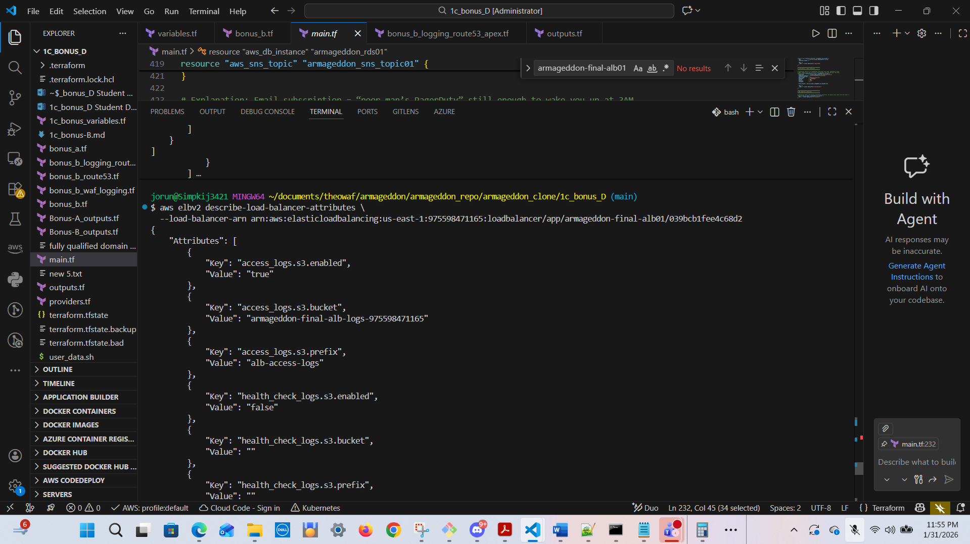

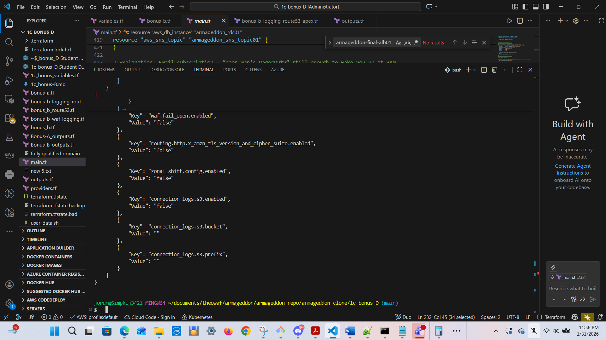

3) Generate some traffic
curl -I https://chewbacca-growl.com
curl -I https://app.chewbacca-growl.com
- OUTPUT
jorun@Simpkij3421 MINGW64 ~/documents/theowaf/armageddon/armageddon_repo/armageddon_clone/1c_bonus_D (main)
$ curl -I app.firstpointand.click
HTTP/1.1 301 Moved Permanently
Server: awselb/2.0
Date: Sun, 01 Feb 2026 05:16:28 GMT
Content-Type: text/html
Content-Length: 134
Connection: keep-alive
Location: https://app.firstpointand.click:443/

jorun@Simpkij3421 MINGW64 ~/documents/theowaf/armageddon/armageddon_repo/armageddon_clone/1c_bonus_D (main)
$ curl --ssl-no-revoke -I https://app.firstpointand.click
HTTP/1.1 200 OK
Date: Sun, 01 Feb 2026 05:40:52 GMT
Content-Type: text/html; charset=utf-8
Content-Length: 233
Connection: keep-alive
Server: Werkzeug/3.1.5 Python/3.9.25

4) Verify logs arrived in S3 (may take a few minutes)
aws s3 ls s3://<BUCKET_NAME>/<PREFIX>/AWSLogs/<ACCOUNT_ID>/elasticloadbalancing/ --recursive | head
- OUTPUT
jorun@Simpkij3421 MINGW64 ~/documents/theowaf/armageddon/armageddon_repo/armageddon_clone/1c_bonus_D (main)
$ aws s3 ls s3://armageddon-final-alb-logs-975598471165/alb-access-logs/AWSLogs/975598471165/elasticloadbalancing/ --recursive | head
2026-01-31 22:36:04 1053 alb-access-logs/AWSLogs/975598471165/elasticloadbalancing/us-east-1/2026/02/01/975598471165_elasticloadbalancing_us-east-1_app.armageddon-final-alb01.039bcb1fee4c68d2_20260201T0340Z_34.238.5.62_2rro8h0v.log.gz
2026-01-31 22:40:04 2642 alb-access-logs/AWSLogs/975598471165/elasticloadbalancing/us-east-1/2026/02/01/975598471165_elasticloadbalancing_us-east-1_app.armageddon-final-alb01.039bcb1fee4c68d2_20260201T0340Z_34.238.5.62_3tod0uyv.log.gz
2026-01-31 22:40:05 1903 alb-access-logs/AWSLogs/975598471165/elasticloadbalancing/us-east-1/2026/02/01/975598471165_elasticloadbalancing_us-east-1_app.armageddon-final-alb01.039bcb1fee4c68d2_20260201T0340Z_52.55.91.4_4xua6f5m.log.gz
2026-01-31 22:50:05 445 alb-access-logs/AWSLogs/975598471165/elasticloadbalancing/us-east-1/2026/02/01/975598471165_elasticloadbalancing_us-east-1_app.armageddon-final-alb01.039bcb1fee4c68d2_20260201T0350Z_52.55.91.4_4hbx4oqr.log.gz
2026-01-31 22:55:04 301 alb-access-logs/AWSLogs/975598471165/elasticloadbalancing/us-east-1/2026/02/01/975598471165_elasticloadbalancing_us-east-1_app.armageddon-final-alb01.039bcb1fee4c68d2_20260201T0355Z_34.238.5.62_1c95jnp8.log.gz
2026-01-31 23:00:05 378 alb-access-logs/AWSLogs/975598471165/elasticloadbalancing/us-east-1/2026/02/01/975598471165_elasticloadbalancing_us-east-1_app.armageddon-final-alb01.039bcb1fee4c68d2_20260201T0400Z_52.55.91.4_4x3ndcr1.log.gz
2026-01-31 23:05:04 1069 alb-access-logs/AWSLogs/975598471165/elasticloadbalancing/us-east-1/2026/02/01/975598471165_elasticloadbalancing_us-east-1_app.armageddon-final-alb01.039bcb1fee4c68d2_20260201T0405Z_34.238.5.62_6bowrv1h.log.gz
2026-01-31 23:10:05 359 alb-access-logs/AWSLogs/975598471165/elasticloadbalancing/us-east-1/2026/02/01/975598471165_elasticloadbalancing_us-east-1_app.armageddon-final-alb01.039bcb1fee4c68d2_20260201T0410Z_34.238.5.62_qxddz5s0.log.gz
2026-01-31 23:10:05 353 alb-access-logs/AWSLogs/975598471165/elasticloadbalancing/us-east-1/2026/02/01/975598471165_elasticloadbalancing_us-east-1_app.armageddon-final-alb01.039bcb1fee4c68d2_20260201T0410Z_52.55.91.4_3um6olgr.log.gz
2026-01-31 23:20:05 788 alb-access-logs/AWSLogs/975598471165/elasticloadbalancing/us-east-1/2026/02/01/975598471165_elasticloadbalancing_us-east-1_app.armageddon-final-alb01.039bcb1fee4c68d2_20260201T0420Z_34.238.5.62_3d1c4d95.log.gz
Why this matters to YOU (career-critical point)
This is incident response fuel:
Access logs tell you:
- client IPs
- paths
- response codes
- target behavior
- latency
Combined with WAF logs/metrics and ALB 5xx alarms, you can do real triage:
“Is it attackers, misroutes, or downstream failure?”

